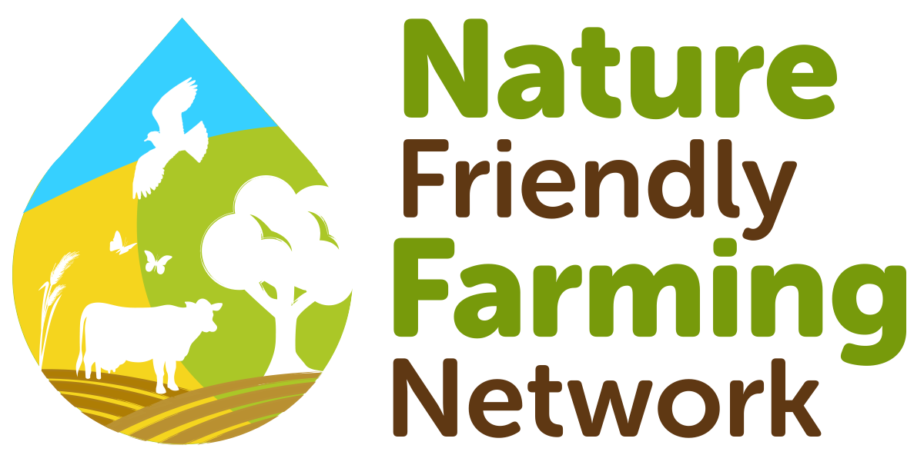

**Job Title: Digital Communications Officer**

**Salary:** £31,000 (£18,600 pro rata)

**Hours:** 22.5 hours per week (preferably spread over 5 days, but not mandatory)

**Contract:** 1-year contract with potential for extension

**Location:** Remote home working anywhere in the UK

**Reporting to:** Head of Communications

The Nature Friendly Farming Network (NFFN) is recruiting an enthusiastic and skilled Digital Communications Officer to join our growing team. This is a fantastic opportunity to learn, grow, grow and drive positive change focused on food, farming and land use.

You will support the Head of Communications and play a key role in creating and managing engaging digital content across various platforms to promote our mission and impact. You will have a talent for storytelling through digital media and are able to translate complex agricultural concepts into engaging content for diverse audiences. You stay on top of the ever-changing digital landscape.

This role is suited to someone who has the enthusiasm to learn and is an excellent communicator. We want someone who is highly self-motivated for a virtual team and thrives in collaboration. We don’t expect you to be an expert in food and farming but we want to see a passion for the environment and a sustainable food system, with a keenness to learn and bring new ideas to the table.

You will have excellent copywriting and written communication skills. As part of a small but experienced team, there will be plenty of scope to work on campaigns, produce creative content and build compelling communications through multiple outputs.

**Key responsibilities:**

Content creation and management

* Developing and implementing a comprehensive digital content strategy aligned with our goals
* Creating compelling written and visual content for the website, social media channels, and newsletters
* Identifying opportunities for developing our social media narrative and presence (incl. trends)

Social media management

* Developing and executing social media strategies across platforms (X, Facebook, Instagram, and LinkedIn), including growing our channel audiences
* Monitoring social media channels and engaging with followers to build a strong online community
* Experience with paid social media advertising and campaign management, including budget allocation and performance analysis.
* Identifying and cultivating relationships with relevant influencers, NFFN’s Farming Champions and partners
* Creating digital assets such as infographics & social media graphics

Website management and SEO

* Overseeing our website to ensure optimal performance
* Conducting regular content audits to identify gaps and ensuring that all information is accurate, relevant, and engaging for users.
* Implement SEO best practices to enhance the website's visibility on search engines

Newsletter

* Planning and creating regular email newsletters to keep subscribers informed about our activities and sector updates
* Analysing campaign performance and making data-driven recommendations for improvement

Analytics and reporting

* Monitoring and analysing website traffic, social media engagement, and newsletter metrics
* Preparing regular reports on digital performance and making recommendations for optimisation
* Staying up-to-date with digital trends and best practices

|  |  |
| --- | --- |
| **ESSENTIAL** | |
| Qualifications | * BA or BSc degree or equivalent experience |
| Experience | * Minimum of 2-3 years working in digital communications * Experience with a range of social media channels and in creating content with demonstrable success * Proficiency in social media management tools (Hootsuite in particular) * Demonstrable success with paid social media advertising * Good understanding of SEO principles and best practices * Ability to work both independently and collaboratively in a fast-paced environment * Strong organisational and project management skills |
| Knowledge, skills and qualities | * Excellent writing and editing skills; ability to write for a variety of audiences in compelling and engaging narratives * Strong interest in environmental, farming and agricultural issues & policies * Use of analytics tools (Google Analytics) * Use of social media scheduling tools (Hootsuite) * Very organised, high attention to detail, high level of accuracy, excellent time management skills and ability to prioritise urgent tasks * High level of creativity with ability to see ideas through to delivery * Team player who is able to work collaboratively towards shared goals and objectives * Flexibility to travel within the UK |
| **DESIRABLE** | |
| Experience | * Experience with photo and video editing software and graphic design (Canva) * Working knowledge of mailing list platforms (Mailchimp) |

**About the NFFN:**

The Nature Friendly Farming Network (NFFN) is a UK-wide, farmer-led organisation championing working with nature to produce food, fibre and other products from our land. At the NFFN, we unite farmers who are regenerating soils, restoring biodiversity and supporting the livelihoods of rural communities, all while putting nutrient-rich, sustainable food on the table. We are a growing movement of producers and growers embracing farm-level solutions to address local, global and interrelated problems, including biodiversity loss, soil depletion, water scarcities, global warming, economic instability and food insecurity. By working together, farmers can produce healthy food, enhance ecosystem function and reverse trends in biodiversity decline while adapting to climate change and becoming more resilient to natural or economic shocks.

Applications close on 29th Sept 2024. Please send your completed application to [info@nffn.org.uk](mailto:info@nffn.org.uk)

If you have any questions, or would like to discuss the role further, please contact [veronique.verlinden@nffn.org.uk](mailto:veronique.verlinden@nffn.org.uk)

Click the link below to download more information and the application form:

<https://www.nffn.org.uk/news/hiring-digital-communications-officer-1>

CVs are not accepted.

We reserve the right to close early if we find the right person for this role.

Thank you for your interest!